Lesson 16

Basics of Testing Mobile Apps

**Test the UI/UX functionality of the “Petsmart” website on a mobile device.**

**Create 5 corresponding bug reports in any document.**

**Bug 1**

| **Title** | An error message pops up during the user registration. |
| --- | --- |
| **Description** | While filling out the Create Account form, an error message is displayed. |
| **Steps** | 1. Launch the [www.petsmart.com](http://www.petsmart.com) 2. Click on the menu bar. 3. Scroll down to the Create Account option. 4. Click on Create Account. 5. Fill out the form. |
| **Expected result** | The user should be able to fill out the form. |
| **Actual result** | The user is interrupted by an error message. |
| **Environment** | iPhone XS, IOS Version 16.6.1 |
| **Severity** | High |
| **Priority** | Low |

**Attachments**

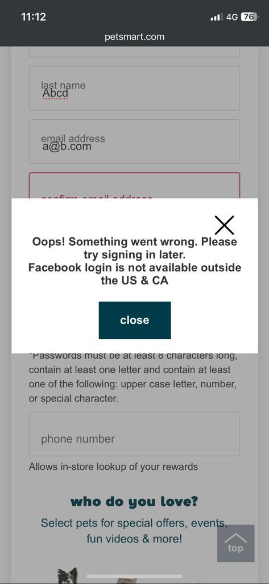

**Bug 2**

| **Title** | Endless loading on the Create Account page. |
| --- | --- |
| **Description** | After the user fills out the form and wants to submit the request, the button  goes into the endless loading. |
| **Steps** | 1. Launch the [www.petsmart.com](http://www.petsmart.com) . 2. Click on the menu. 3. Go to Create an Account. 4. Fill out the form. 5. Click on: NO, I do not want texts at his time. 6. Click Join. |
| **Expected result** | The user should be able to Create Account. |
| **Actual result** | The user is not able to Create Account. |
| **Environment** | iPhone XS, IOS Version 16.6.1 |
| **Severity** | Critical |
| **Priority** | High |

**Attachments**

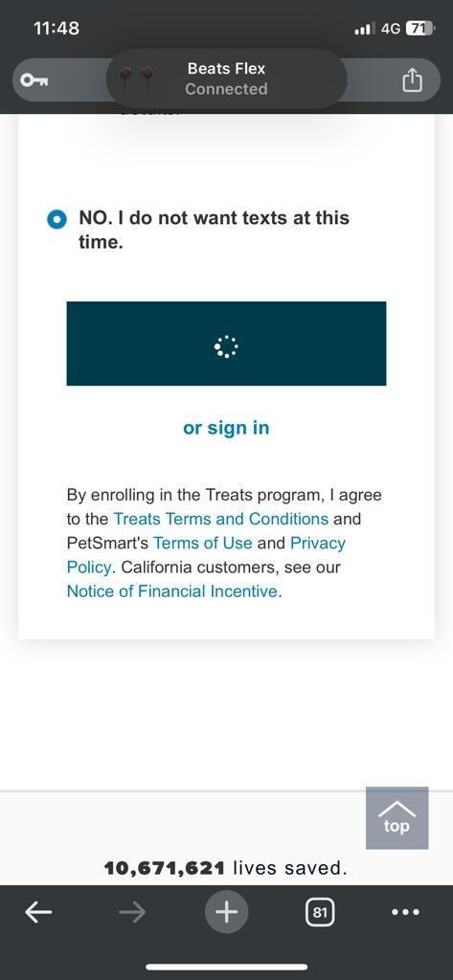

**Bug 3**

| **Title** | Error message when the user’s adding the product to cart |
| --- | --- |
| **Description** | When a user wants to make a purchase an error message is displayed. |
| **Steps** | 1. Launch the [www.petsmart.com](http://www.petsmart.com) . 2. Click on the menu. 3. Select Dog. 4. Click on Food. 5. Click on Canned Food. 6. Select the: Simply Nourish Original Adult Wet Dog Food - 10 Oz., Stew 7. Click on Shipping. 8. Choose any quantity from the list. 9. Add to cart. |
| **Expected result** | The user should be able to buy the product. |
| **Actual result** | The user is not able to buy the product. |
| **Environment** | iPhone XS, IOS Version 16.6.1 |
| **Severity** | Critical |
| **Priority** | High |

**Attachments**

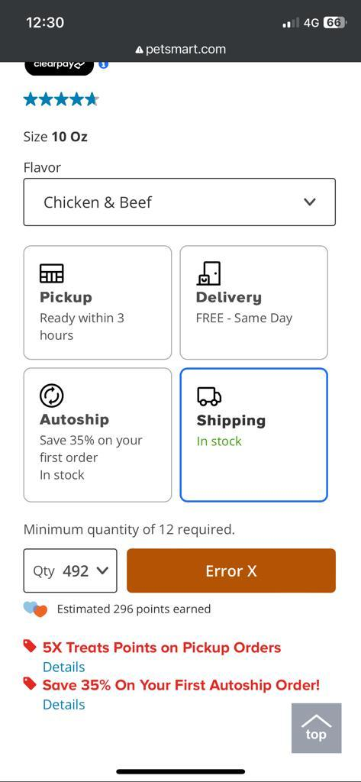

**Bug 4**

| **Title** | User cannot book a grooming for his pet. |
| --- | --- |
| **Description** | On the pet grooming service on the website, the user is experiencing a bug  when trying to book an appointment for his pet. The issue results in not being  able to introduce the email address. |
| **Steps** | 1. Launch the [www.petsmart.com](http://www.petsmart.com) . 2. Go to the map icon. 3. Scroll down to Find a Store. 4. Search Kansas. 5. Book a Grooming on the first store displayed. 6. Click on the login or create account. 7. Introduce the email address. |
| **Expected result** | The user should be able to create an account and book a grooming. |
| **Actual result** | The user cannot create an account or book a grooming. |
| **Environment** | iPhone XS, IOS Version 16.6.1 |
| **Severity** | Critical |
| **Priority** | High |

**Attachments**

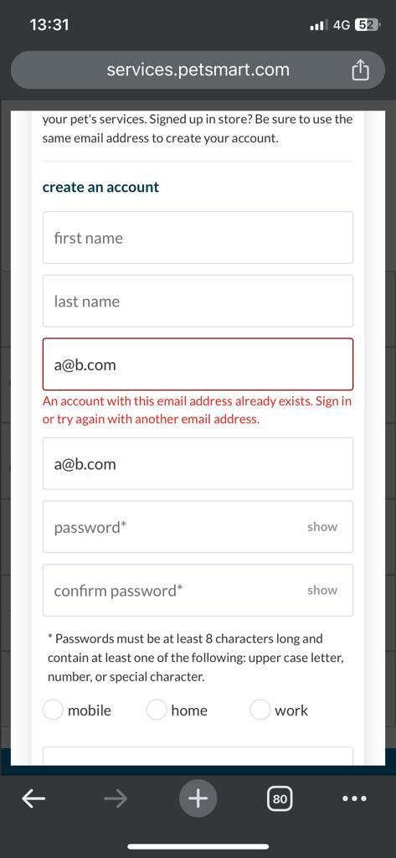

**Bug 5**

| **Title** | The app cannot be downloaded. |
| --- | --- |
| **Description** | The user cannot download the app from the App Store. |
| **Steps** | 1. Launch the [www.petsmart.com](http://www.petsmart.com) . 2. Scroll down to the Download on the App Store. 3. Click on the Download on the App Store. |
| **Expected result** | The user should be able to download the app. |
| **Actual result** | The user cannot download the app. |
| **Environment** | iPhone XS, IOS Version 16.6.1 |
| **Severity** | Critical |
| **Priority** | High |

**Attachments**



Level 2

**Find 3 bugs on the “VolkswagenParts” website. Add their bug reports to the document from the previous level.**

**In the bug reports, place screenshots/videos showing that the testing was performed from the emulator.**

**Bug 1**

| **Title** | The cart button is overlapping the counter button. |
| --- | --- |
| **Description** | When the user wants to make a purchase, the cart button overlaps the counter button, making adding more products to the cart difficult. |
| **Steps** | 1. Launch the [www.vwparts.nyc](http://www.vwparts.nyc) . 2. Scroll down to the Volkswagen Drive Gear. 3. Select Headwear from the displayed menu. 4. Click on Basic Cap. |
| **Expected Result** | The user can add and take out products from the cart using the counter button. |
| **Actual Result** | The user cannot add more products to the cart easily. |
| **Severity** | Low |
| **Priority** | Medium |

**Attachments**

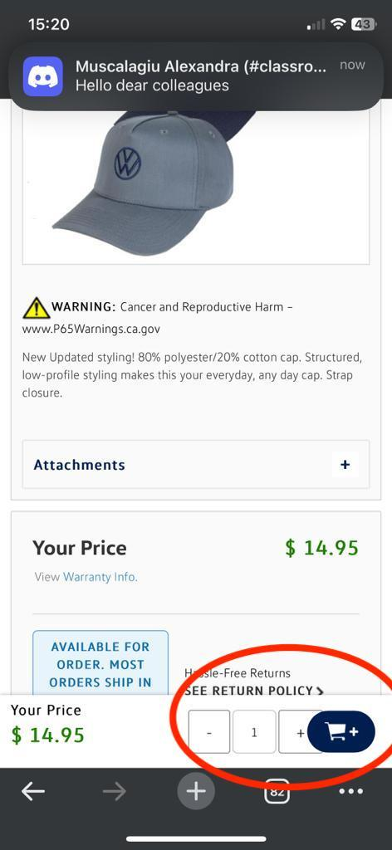

**Bug 2**

| **Title** | Failled redirection to Pinterest page. |
| --- | --- |
| **Description** | When the user wants to get redirected to the Pinterest, he is redirected to an error page. |
| **Steps** | 1. Launch the [www.vwparts.nyc](http://www.vwparts.nyc) . 2. Scroll down to the bottom of the page. 3. Click on the Pinterest icon. |
| **Expected Result** | The user is redirected to the Pinterest page. |
| **Actual Result** | The user is redirected to a new page and an error message is displayed. |
| **Severity** | High |
| **Priority** | Low |

**Attachments**

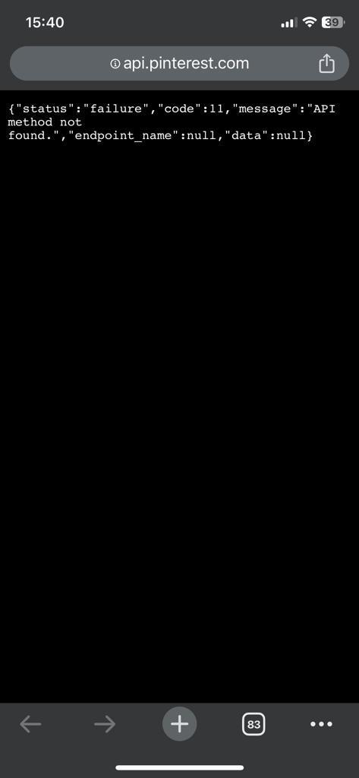

**Bug 3**

| **Title** | Page doesn’t exist. |
| --- | --- |
| **Description** | The Vehicle Recall option is not available. |
| **Steps** | 1. Launch the [www.vwparts.nyc](http://www.vwparts.nyc) . 2. Scroll down to the page’s footer. 3. Click on the Vehicle Recall Option. |
| **Expected Result** | The user is able to open the requested option. |
| **Actual Result** | The user is redirected to a new page that displays an error message. |
| **Severity** | Critical |
| **Priority** | Medium |

**Attachments**

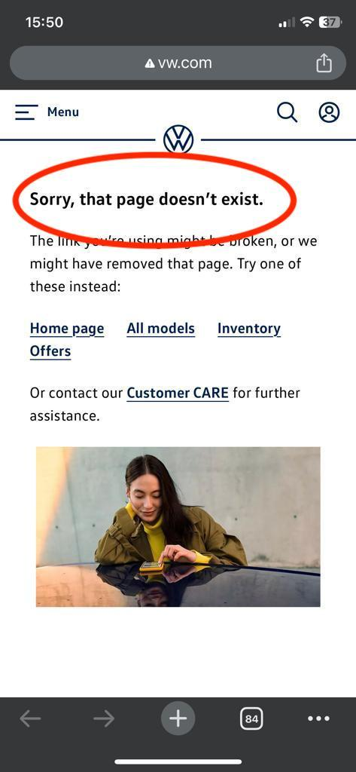

Level 3

**Install the “Instagram” app to your mobile device.**

**Create a checklist for testing this app with sections for different types of testing.**

**The checklist should contain at least 4 types of testing and at least 5 tests of each type.**

**Functional Testing:**

1. **Login and Authentication:**

* Verify that users can create a new account.
* Test login functionality with valid credentials.
* Test login functionality with invalid credentials.
* Check password reset functionality.
* Test two-factor authentication (if enabled).

1. **Profile and Content:**

* Test the ability to create a new post (photo or video).
* Check if users can delete their own posts.
* Verify that users can edit their profile information.
* Test the ability to like and comment on posts.
* Ensure that users can follow and unfollow other users.

1. **Direct Messaging:**

* Test sending direct messages to other users.
* Check group messaging functionality.
* Verify that users can receive and read messages.
* Test message notifications.
* Ensure that messages can be deleted.

1. **Search and Discovery:**

* Test the search functionality for finding users and hashtags.
* Check the Explore feature for discovering content.
* Verify that suggested user accounts are accurate.
* Test the "Discover People" feature.
* Ensure that content is displayed based on user interests.

1. **Settings and Privacy:**

* Test privacy settings, such as making an account private.
* Verify that account deactivation and deletion options work.
* Test notification settings and preferences.
* Check the security and login settings.
* Ensure account information can be updated successfully.

**Usability and User Experience Testing:**

1. **Onboarding and User Guidance:**

* Evaluate the onboarding process for new users.
* Test the user guidance and tooltips.
* Check if user interface elements are intuitive.
* Test the "Help Center" or user support features.
* Verify the clarity of error messages.

1. **Performance and Loading Times:**

* Test app loading times on different devices.
* Evaluate the speed of loading images and videos.
* Check the smoothness of scrolling and transitions.
* Test the app's responsiveness during interactions.
* Verify the performance on various network connections.

1. **Cross-Platform Compatibility:**

* Test the app on different mobile devices (iOS and Android).
* Check for compatibility with various operating system versions.
* Test the app in different screen sizes and resolutions.
* Verify landscape and portrait orientations.
* Ensure compatibility with popular web browsers (if web version exists).

1. **Accessibility and Inclusivity:**

* Evaluate the app's accessibility features for users with disabilities.
* Test screen reader compatibility.
* Verify that alt text is available for images.
* Test color contrast for text and background.
* Check font sizes and readability.

**Security Testing:**

1. **Data Privacy and Permissions:**

* Verify that the app requests and handles user permissions appropriately.
* Test data encryption during transit and at rest.
* Ensure that private content remains private.
* Test for any potential data leaks or vulnerabilities.
* Verify the effectiveness of account recovery and security features.

1. **Authentication and Authorization:**

* Test the security of user authentication.
* Verify authorization controls for different user roles.
* Test session management and user access control.
* Check for any unauthorized access or actions.
* Ensure secure transmission of login credentials.

1. **Content Moderation**

* Test the app's content filtering and reporting mechanisms for inappropriate or abusive content.
* Verify that reported content is reviewed and acted upon promptly.

1. **API Security:**

* Verify the security of APIs used by the app.
* Check for rate limiting to prevent abuse.
* Ensure that APIs require proper authentication and authorization.
* Test for data leakage through APIs.

**Performance Testing:**

1. **Load Testing:**

* Test the app's performance under heavy user loads.
* Check how the app handles concurrent users.
* Evaluate the response time during peak usage hours.
* Test for server scalability.

1. **Stress Testing:**

* Subject the app to extreme conditions, such as high traffic or resource constraints.
* Verify the app's stability under stress.
* Test for graceful degradation during stress scenarios.
* Monitor the app for potential crashes or errors.

1. **Network Performance:**

* Test the app's performance on different network types (Wi-Fi, 4G, 3G).
* Check for content loading delays on slower networks.
* Test the app's ability to resume content download after network disruptions.
* Verify the efficiency of data synchronization.

1. **Resource Consumption:**

* Evaluate the app's memory usage over time.
* Test battery consumption during prolonged app usage.
* Check for resource leaks and memory management.
* Verify that the app doesn't excessively drain device resources.

1. **Cache and Data Management:**

* Test the app's caching mechanisms for efficiency.
* Check if cached data is refreshed correctly.
* Test data synchronization across devices.
* Verify that cached data is secure and private.